**Machine Learning**

**What does it do?**

Machine learning (ML) has become an increasingly important part of IT today. It is seen in how IT leverages machine learning to improve operations and how IT supports and enables different life and business applications. Machine learning is an application of artificial intelligence (AI) that provides systems the ability to automatically learn and improve from experience without being explicitly programmed. “Some specialists believe that **machine learning applications** are, on the one hand, magic boxes capable of doing whatever we want or, conversely, are alien-like solutions that are useless in everyday life” (r3). What may seem useless on the surface, actually has real world applications now and into the future.

Currently machine learning AI is used in broad range of applications that not only speed up data delivery but enhance an applications useability**. Real-world applications include speech and image recognition, text classification and web search optimization. Ever wondered how Google search knows what you are typing before you finish typing it? Machine learning. To create this predictive behaviour, ML algorithms are trained. “A machine learning model is the output generated when you train your machine learning algorithm with data” (r1). This predictability allows Google to preload search results and or webpages, enabling a quicker response. Similarly, application such as Netflix employ ML to predict better content suggestions for viewers. After the trained algorithm is enable the predictive nature becomes more accurate through ‘trial and error’ based on the user’s actions. Essentially Netflix algorithms learn, I like action movies and suggests more movies around this genre. Although this predictability function is a small fraction of the capabilities of machine learning, it can be easily demonstrated how this technology can speed up data transfer and enhancing user experience.**

***“Machine learning is not a simple process. As the algorithms ingest training data, it is then possible to produce more precise models based on that data. A machine learning model is the output generated when you train your machine learning algorithm with data. After training, when you provide a model with an input, you will be given an output. For example, a predictive algorithm will create a predictive model. Then, when you provide the predictive model with data, you will receive a prediction based on the data that trained the model”. (r1)***

**Whilst ML is not new, recent hardware technology advancements has allowed ML to do more complex calculations. As these algorithms become more complex, the processing power of the CPU (central processing unit) became less capable of handling the enormous amount of data. However, graphical processing unit (GPU), which originally developed for the gaming industry, has now become popular for machine learning AI. “**GPUs are specialized hardware for the manipulation of images and calculation of local image properties. The mathematical basis of neural networks and [image manipulation](https://en.wikipedia.org/wiki/Graphics_pipeline) are similar, [embarrassingly parallel](https://en.wikipedia.org/wiki/Embarrassingly_parallel) tasks involving matrices, leading GPUs to become increasingly used for machine learning tasks” (r1). Not only are GPUs able to process the enormous amount of data, GPU development is evolving in a direction that facilitates deep learning.

Similarly, An AI accelerator is a class of microprocessor or computer system designed as hardware acceleration for artificial intelligence applications such as machine learning. “Like other purpose-built accelerators, such as graphics processing units ([GPUs](https://searchvirtualdesktop.techtarget.com/definition/GPU-graphics-processing-unit)), AI accelerators are designed to perform their particular tasks in a way that’s impossible for traditional [CPUs](https://whatis.techtarget.com/definition/processor) in most desktops and notebooks. A purpose-made accelerator delivers greater performance, more features and greater power efficiency to facilitate it’s given task” (r4). Whilst some believe GPUs are the dominant hardware architecture, recent developments of “neural network processing units (NNPUs), field programmable gate arrays (FPGAs), application-specific integrated circuits (ASICs), and various related approaches that go by the collective name of neurosynaptic architectures” (r5), will lead machine learning into the future with more complex and higher capabilities.

**What is the Impact?**

With a huge number of applications of ML and the advancement in the development of hardware, the impacts are far reaching from the home to large corporations. It is not easy to say which sector will be impacted the most with the advancement of this technology. It has been argued over the last decade, whether machine learning or AI will replace people in the work place or just change where those jobs are. However, corporations and business owners will benefit greatly from this technology and it will greatly change the way in which they operate.

Large corporations stand to profit more through increased statistics and performance analytics and customer profile generation. Accurate statistic and performance data, will give corporations the necessary data to create better processes or change their operating structure of particular departments. With better process in place, organization can stream line operations and increase their productivity through reduced resource waste. This reduction of waste will generate lower overheads and will lead to greater profitability. Higher profits will also be generated through better understanding of their customers. Machine learning offers potential value to companies trying to leverage big data that helps them better understand subtle changes in behaviour, preferences or customer satisfaction. This data can be gathered through social media post/reactions, customer surveys, loyalty programs etc. A greater understanding of their customer profile enables corporations to specifically target marketing campaigns to increase sales, or rectify issues that cause a negative impact for their customers. Machine learning leverages the necessary information corporations need to successfully increase efficiency and interact with their customers, not only increasing their profitability but customer satisfaction.

Whilst reducing resource waste and creating efficiency is key to a changing business. It can however have a negative side effect to the blue-collar workforce that they employ. Machine learning, through its effects on stream lining business operations, can cause a reduction in workforce numbers as a smaller more efficient workforce can accomplish the same task. Certain positions such as personal assistance, HR representatives, data analysts etc. also have the potential to be replaced with ML based programs. This subsequent change to business operations changes the job market significantly. However, it can also be argued that ML will only replace the meaningless tasks, allowing humans to focus on the more important aspects of their occupation. With a wide range of ML applications, the impact will be assessed individually. Although it can be said, over all the greatest impact will come from the work sector.

**How will it affect you?**

Fortunately, I am in a position where ML will only compliment both my personal and professional life. Professionally I work for an IT company in the field as a technician. The work performed on a daily basis is mainly physical, an area where ML is unable to operate. However, ML can play a supporting role in diagnosing issues related to either network implementation or programming. With the correct algorithms, ML can detect and apply changes to code as they are inputted or run a series of diagnostic tests across a platform to correct errors. Personally ML is very complimentary to my life style, from subtle application in web searching to Netflix recommendations. I expect ML to be incorporated into connected home setup in the near future. Biometric sensors would register who entered the particular room and adjust the room settings to suit. This would be achievable through face recognition and learned behaviour patterns to determine correct environmental settings. The impact on family and friends will ultimately come down to case by case basis. How ML will impact their lives will be down to their individual circumstances and how this technology will incorporate into their lives. As my parents age, I would expect to see a health monitor utilized to assist in medical diagnosis. Technology is what you make of it, some people embrace it and others reject it. However, the technology is inevitable, but we should endeavour to get the balance right.

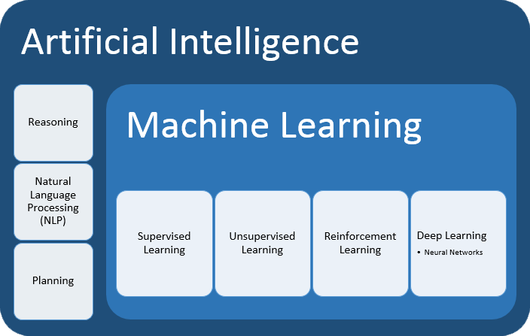

Reference: (r)

1.<https://www.ibm.com/analytics/machine-learning>

2.<https://en.wikipedia.org/wiki/Machine_learning#Applications>

3.<https://www.sas.com/en_au/insights/analytics/machine-learning.html>

4. <https://searchenterpriseai.techtarget.com/definition/AI-accelerator>